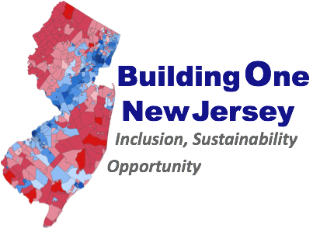
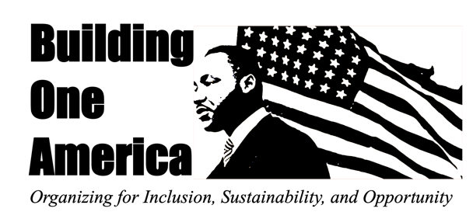

Building One New Jersey Statement on S820
Establishing the Division of School Desegregation in in the NJ Department of Education

February 3, 2022
Senate Bill 820, sponsored by Senator Joe Cryan, is a well-intentioned first step in moving us closer to addressing the horrendously shameful and opportunity-destroying reality of school segregation in our state. Considering the depth of the crisis and the ever-widening gaps of learning and life chances for too many children in our state, the bill in its current form, is woefully inadequate.
A bill establishing a division of school desegregation should be enacted-but only with significant amendments, and as a part of a comprehensive, multi-pronged legislative and administrative approach to dismantling all the structures that create and reinforce school segregation by race and class across the state. Such an approach would require:
- A legislative mandate to bring the State of New Jersey into compliance with its own constitutional requirement of guaranteeing a thorough and efficient education for all students free of racial segregation.
- The Department of Education must be required to conduct, and adequate resources must be allocated for, an analysis of all New Jersey school districts-including demographics and fiscal capacity across school district boundaries within metropolitan regions and across the state (not just within school districts). It must be provided with and authorized to obtain the tools and expertise needed to carry out a desegregation plan that includes integration goals for each district and school based on their relative compliance with school integration.
- A position and division created to lead the desegregation of New Jersey’s schools (such as a Division and Director of Desegregation) must be an adequality funded, dedicated, and a specialized role with independence and statutory authority to carry out a school desegregation mandate.
- The strategies available to such a Division and Director of School Desegregation must include all tools, policies and programs that can incentivize and promote established integration goals set for each school district. The division must be required to ensure that all programs and decisions of the Department of Education advance the goals and are in full accord with the principles of desegregation-including charter schools, magnet schools, any changes to send-receive relationships the use of the Interdistrict Sharing program.
- Other changes must be introduced in the legislature that will be required to advance a school desegregation plan. Those changes to existing legislation must include the following:
- We must expand and strengthen the state school funding formula to advantage and incentivize diverse and integrated schools.
- We must direct and increase state school funding to support and incentivize local integration and desegregation best practices where diversity already exists.
- We must reform the Interdistrict Public School Choice program to become a mandatory tool to advance integration within regions based on an opportunity analysis.
- We must require charter schools to advance integration and meet regional inclusion goals.
- We must create and support pro-integration magnet schools in urban areas and require county schools to meet regional integration goals
- We must end secessions; ban the termination of regional send-receive arrangements and the dissolution of unified districts. We must amend the school consolidation bill to prohibit secessions while requiring an affirmative obligation to create integrated districts.
- We must strengthen the Fair Housing Act to Increase Mount Laurel obligations on “far flung” wealthy communities with exclusionary schools.
In the past two years the State of New Jersey has not only failed to address segregation it has increased and deepened it through new segregationist secessions and a school consolidation bill that will allow for and subsidize more secessions. Unless the state’s leadership is committed to a comprehensive approach to ending school segregation, minor changes to the Department of Education or the creation of a title without a real mandate, the teeth, or tools will only further the illusion that we are doing something when in fact we are doing nothing.

In 2019, The Murphy Administration approved the separation of majority white Maywood schools from majority Black and Brown Hackensack High School in clear violation of the New Jersey Constitution. In 2020, The Murphy Administration accepted and is now considering a petition to separate majority white Absecon Schools from Majority Black and Brown Pleasantville High School.
In 2022 the New Jersey Legislature passed, and Governor Murphy signed into a law, a new school district “consolidation bill” that will allow for and pay for the separation and dissolution of school districts in New Jersey.

