Warden Smith Does Not Speak for Us
Governor Murphy Should Be Uninvited to the NAACP Convention

...I do not savor your sacred assemblies. Though you offer me burnt offerings and your grain offerings, I will not accept them, nor will I regard your fattened peace offerings. But let justice run down like water, and righteousness like a mighty stream! Amos 5:22-27
When America's preeminent civil rights organization holds its national convening in our state, its delegates should expect to see justice and righteousness proudly displayed. But where there is injustice, racism, and wickedness it too must be visible so it can be exposed and condemned – not swept under the rug!
In New Jersey (and Atlantic City where the NAACP convention will be held) a multitude of injustices are committed daily against poor and working-class parents, employees, students, and even prison inmates.
Despite its “progressive” reputation, New Jersey is one of the most shockingly separate and shamefully unequal places in America. Its schools are among the nation’s most segregated. It has one of the worst racial wealth gaps in the country with Atlantic City ranking highest in income inequality. And New Jersey has the highest rate of racial disparities in its prison population, with Black residents incarcerated at a rate of 12.5 times that of whites.
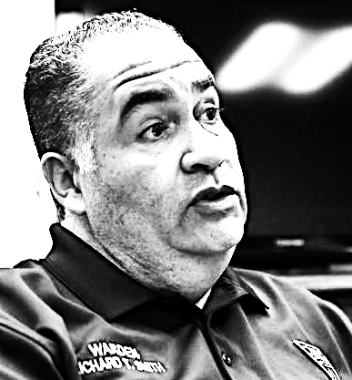
We want all NAACP delegates to enjoy their stay as they recommit to their organization’s historic mission to fight injustice and promote opportunity. But the national NAACP cannot simply ignore grotesque disparities and civil rights violations being tolerated (or worsened) by employers, elected officials, even NAACP officials in the host state.
The New Jersey Coalition Against Racial Exclusion (part of Building One America and the Summit for Civil Rights) has been fighting to end the intense segregation of our public schools. But Governor Murphy feels no need to act on this critical civil rights issue. Repeated overtures over the past 3 years including letters, public meetings, and demonstrations have not swayed him to even meet with our leadership.
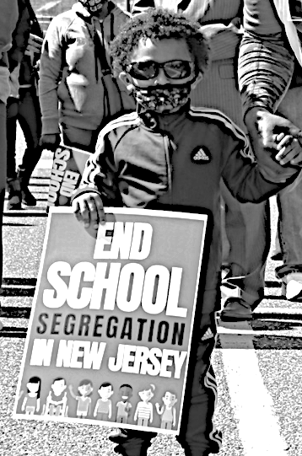
NJ-CURE had no choice but to call on State Conference President Richard Smith, to uninvite Governor Murphy to the NAACP National Convention. We are fully aware of the Governor’s history with the organization including as a board member and major donor. But there must come a point when no amount of money or influence should grant immunity to the powerful for their continued inaction against injustices exacted against the powerless.
Sadly, President Smith refused our request preferring to drape the cloak of civil rights on a Governor who has only fought integration while worsening segregation. But Warden Smith does not have the final say on civil rights in New Jersey…you do!
Sign-on to a letter to NAACP President and CEO Derrick Johnson and Board. Tell them that Richard Smith does not speak for you or for the million children attending segregated schools in our state. Ask them to uninvite Phil Murphy and remind him of his pledge to the NAACP and his allegiance to its principles - especially to oppose school segregation.
We are thrilled the NAACP decided to come to our state but not because of the business or even prestige it will bring. We want the NAACP to bring all its awesome influence and all its enormous moral authority so that, together, we can unleash the powerful waters of justice and send a mighty wave of righteousness across this state and nation.

